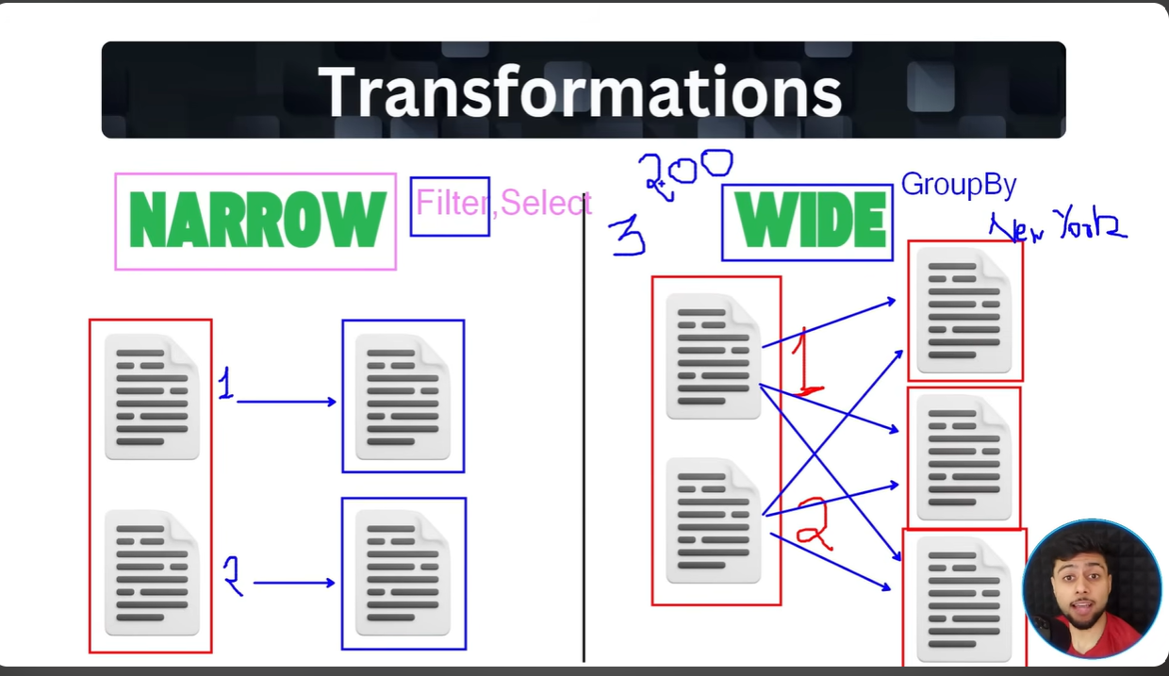
Refer this for coding and understanding plans : https://dbc-e409b028-0a41.cloud.databricks.com/editor/notebooks/97372252888689?o=7474645623127556#command/4759082041973335

